**Content for Parent Newsletters**

**HEALTH PROMOTING SCHOOLS**

February 2025

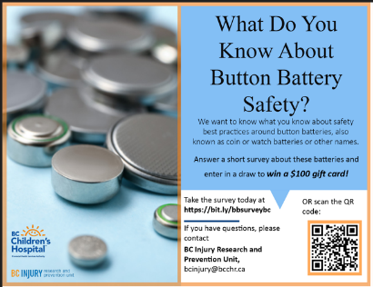**INJURY PREVENTION**

**Button Battery Survey & Website**

The BC Injury Research Prevention Unit is conducting a short [survey](https://bit.ly/bbsurveybc) to determine what British Columbians know about button batteries.

Additional information on button battery safety can be found on [BCIRPU](https://www.injuryresearch.bc.ca/injury-priorities/button-battery-safety) and at Parachute Canada [Around the house – Parachute](https://parachute.ca/en/injury-topic/home-safety/aound-the-house/).

**LEGAL SUBSTANCES AND HARM REDUCTION**

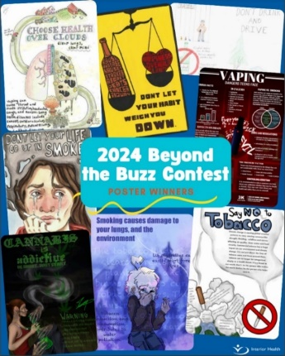**How does substance use impact youth? See what students had to say!**

On the third week of January, as Canada marked [National Non-Smoking Week](https://can01.safelinks.protection.outlook.com/?url=https%3A%2F%2Fwww.canada.ca%2Fen%2Fpublic-health%2Fnews%2F2025%2F01%2Fstatement-from-the-council-of-chief-medical-officers-of-health-on-nicotine-vaping-in-canada-as-part-of-national-non-smoking-week.html&data=05%7C02%7CValerie.Pitman%40interiorhealth.ca%7Cf2db0b59bb7246b974cf08dd3caabbe6%7C31f660a5192a4db392baca424f1b259e%7C0%7C0%7C638733426187261619%7CUnknown%7CTWFpbGZsb3d8eyJFbXB0eU1hcGkiOnRydWUsIlYiOiIwLjAuMDAwMCIsIlAiOiJXaW4zMiIsIkFOIjoiTWFpbCIsIldUIjoyfQ%3D%3D%7C0%7C%7C%7C&sdata=wHzvmncPYboNI4Rei0X1xI%2Fwha4LKIkmkeqcIgIKFUw%3D&reserved=0), the Legal Substances Team celebrated the creativity and voices of young people in a big way! The winners of this year’s ***Beyond the Buzz: Youth Voices on Tobacco, Cannabis, Vaping & Alcohol*** poster contest were announced, showcasing powerful messages about how tobacco, cannabis, vaping products and alcohol affect youth, their families, and their communities.

Launched annually in October, the contest this year invited students in grades 6 to 12 to express their perspectives through original artwork. A panel of teen judges from the IH YOUTHWISE Advisory Council selected eight standout pieces from dozens of inspiring entries.

The winning artists will be receiving a $150 gift card and will see their posters displayed in schools, health care facilities, and community centers across the Interior region, as well as shared across social media. Congratulations to our 2024 contest winners—their creativity is helping to spark important conversations about substance use! See the winning posters and learn more about the contest at <https://www.interiorhealth.ca/information-for/youth/beyond-the-buzz-contest>

**MENTAL HEALTH**

**Education Opportunity for Parents**

FamilySmart Connect & Learn

[ONLINE EVENT: ADHD – The Real Deal](https://can01.safelinks.protection.outlook.com/?url=https%3A%2F%2Ffamilysmart.ca%2Fevent%2Fadhd-the-real-deal-13%2F&data=05%7C02%7CValerie.Pitman%40interiorhealth.ca%7C4c8b7dc04abe4f71ba0308dd3fd4f04b%7C31f660a5192a4db392baca424f1b259e%7C0%7C0%7C638736905973696992%7CUnknown%7CTWFpbGZsb3d8eyJFbXB0eU1hcGkiOnRydWUsIlYiOiIwLjAuMDAwMCIsIlAiOiJXaW4zMiIsIkFOIjoiTWFpbCIsIldUIjoyfQ%3D%3D%7C0%7C%7C%7C&sdata=WiwvK1R13pnXgk3vlC8ksEtEBXxXTVwP0wjRWpkZQiQ%3D&reserved=0)

Date: February 6

Time: 6:30 pm - 8:00 pm PST