Content for Parent Newsletters
HEALTH PROMOTING SCHOOLS
September 2025
MENTAL HEALTH

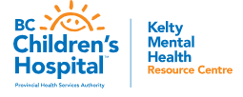
Kelty Mental Health has several resources, podcasts and events just in time for back to school!
- Recognizing Teen Anxiety: How to Support Your Child. Find videos and information on mental health topics in multiple languages through Linktree on Kelty’s Instagram page.
- School Anxiety: Getting Your Child Back to Their School Routine - Podcast. When anxiety gets in the way of a child going to or staying at school, this can be hard on the whole family. This episode looks at what’s behind school anxiety, when parents should reach out for help, tips for parents and caregivers to promote their own coping, and strategies to help getting children back in their school routine. Listen here.
- ADHD - The Real Deal – FamilySmart Online Event. ADHD doesn't just affect the person living with ADHD. It also affects those around them. Parents of kids living with ADHD, can benefit from learning what ADHD is and how to support kids. Learn from Dr. Duncan, Child and Adolescent Psychiatrist, as he dispels some myths and explains how and why the ADHD brain works the way it does. For dates and to register click here.

PHYSICAL LITERACY
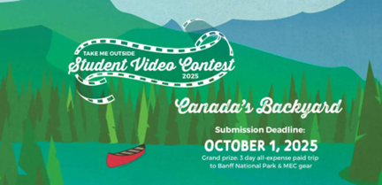
Take Me Outside Student Video Contest: 2025

Calling all K-12 students! Submit a short film about your favorite outdoor spot for a chance to win a 3-day trip to Banff National Park and $400 in MEC gear. The contest closes October 1, 2025. See the Official Rules & Guidelines for more information. Contest Closes: October 1, 2025

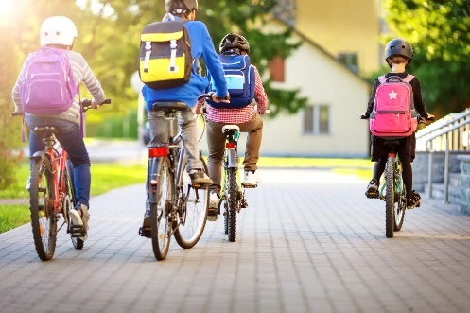
Thinking about sending your child to school on a bike?

Have a look at Active for Life’s How to create your own back-to-school bike rodeo. Bike rodeos are a great way to ensure that children have the skills and confidence to ride to school. The site also includes a great infographic for parents to help assess their child’s skill level to see if they are ready to roll!

